# TEC HD DMPS and touch panel modes (input configurations) that are allowed

Mode 1:

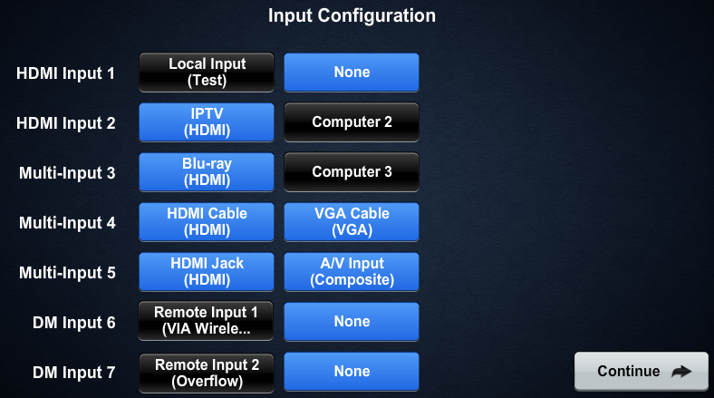

For modes involving multiple names (HDMI Input 1, HDMI Input2, DM Input 6, and DM input7). Each button will cause a different icon and text to be displayed. As in this example from DM Input 6:

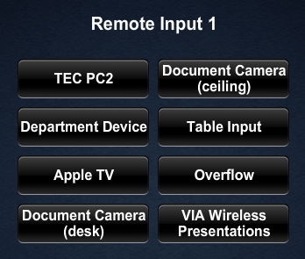

The text on this button is custom and can be anything that fits.



Mode 2:

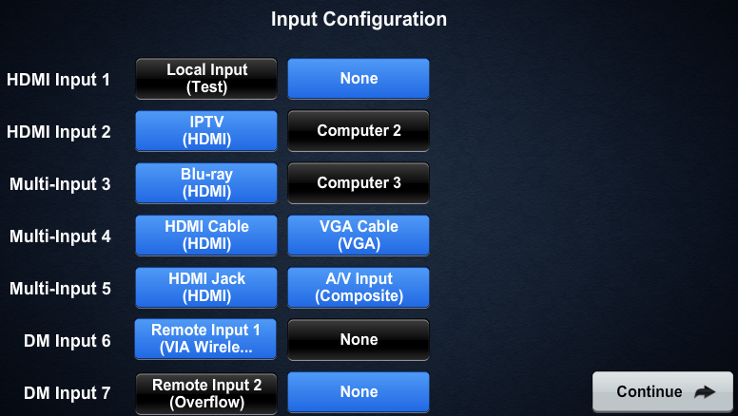

DM Input 7:

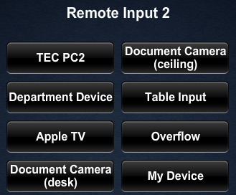

The text on this button is custom and can be anything that fits.



Mode 3:

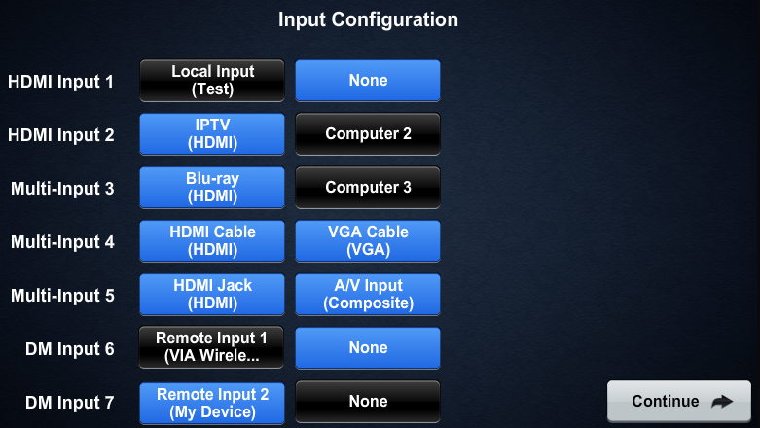

Mode 4:

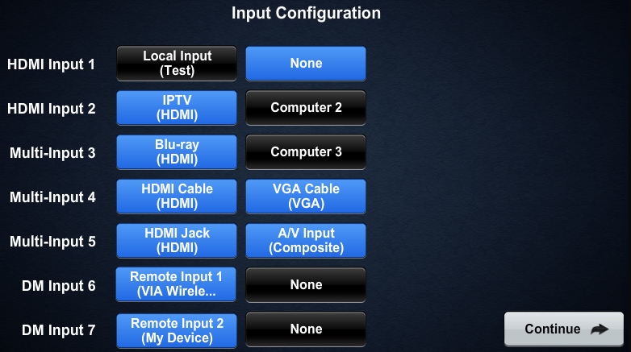

HDMI Input 1:

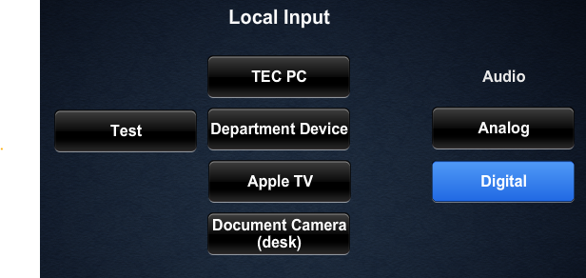



The text on this button is custom and can be anything that fits.

Mode 5:

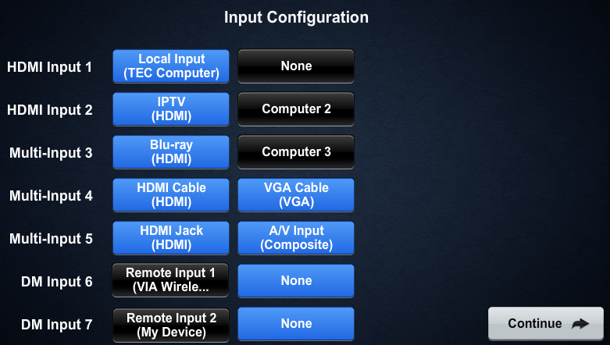

Mode 6:

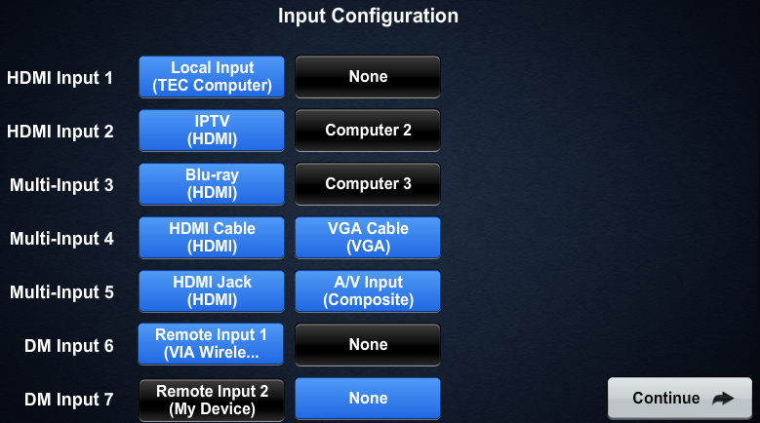

Mode 7:

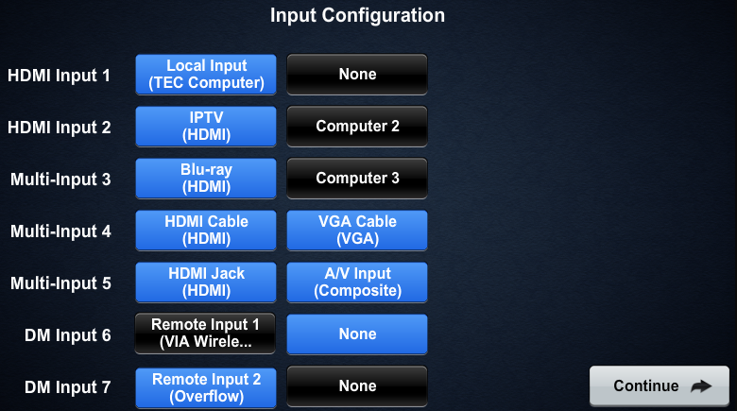

Mode 8:

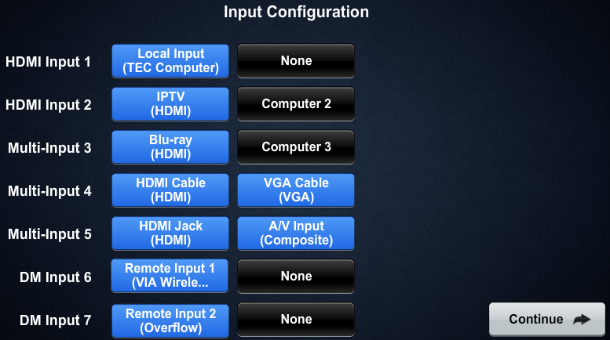

Mode 9:

